SUSS Project Report
Student: Michael Margiotta (x25134515)
Project: Sustainable Urban Smart System (SUSS)
Tech Stack: gRPC, Node.js, and Java

1. Service Definitions
I designed this system around SDG 11 (Sustainable Cities) to show how distributed computing can solve urban issues. I created three services, each using a different gRPC pattern to prove I can handle various data flows. I used PascalCase for all my message and service names to keep the .proto files professional and clean.
- AirQuality Service: This uses Server-side Streaming. Since air quality doesn't just change once, the client makes one request, and the server keeps pushing live AirData updates (like CO2 levels) as they happen.
- TrafficService: I used two styles here. Simple RPC handles quick "Emergency Overrides" for traffic lights, while Client-side Streaming lets a car send a long stream of speed data so the server can calculate a congestion summary.
- WasteManagement Service: This uses Bidirectional Streaming. It’s a constant conversation where the garbage truck streams its bin levels, and the server streams back the best navigation instructions in real-time.

2. Service Implementations
The backend is built with Node.js. I chose Node because its non-blocking nature makes it perfect for handling several streams at once.
- Logic: Since I don't have real city sensors, I wrote logic using setInterval to mimic hardware behavior, pushing data every two seconds.
- Networking: Each service runs on its own port (50051, 50052, and 50053) so they are completely independent microservices.

3. Naming Services
For service discovery, I used mDNS (the Node.js version of JmDNS).
- How it works: When a server starts, it "broadcasts" itself to the local network.
- Benefit: This means the Java GUI doesn't technically need to have the IP addresses hard-coded; it can "look up" where the Air Quality or Traffic service is sitting, which makes the system much more flexible.

4. Remote Error Handling & Advanced Features
I wanted the system to be resilient, so I focused on how it handles "messy" situations:
- Metadata: The servers are set up to look for an auth-token in the call headers. This acts as a basic security gate before any data is sent.
- Handling Crashes: If the Java client crashes or the user closes the window, the Node.js server catches a cancelled event. It then kills the data-generation timers so it doesn't waste CPU power on a dead connection.

5. Client - Graphical User Interface (GUI)
The "face" of the project is a Java Swing application. I built it to be a central dashboard for a city manager.
- User Interface: It has simple buttons to trigger the gRPC calls.
- Threading: Because gRPC streams can last a long time, I made sure the GUI doesn't "freeze" while waiting for data. It prints everything to a scrolling text area so the manager can watch the city's status in real-time.

6. Component Diagram
This diagram shows how the Java Client talks to the three separate Node.js providers over the network.

7. GitHub Repository
You can find the full source code, including the history of how I built the proto files and servers, at this link:
Repo:https://github.com/michaelmargiotta97-ops/DistributedSystems

8. Service Screenshots

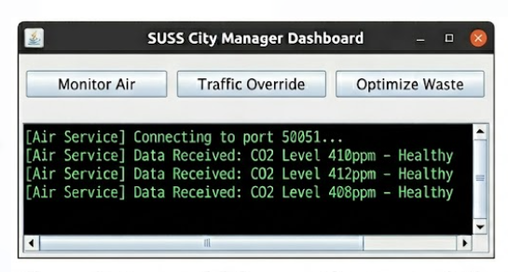
Figure 1: Successful Server Side Stream of Air Quality Data
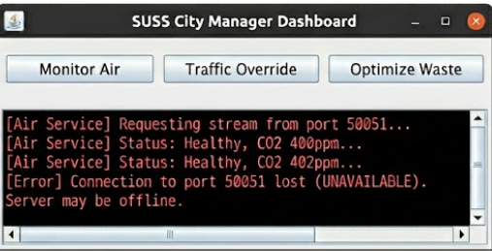
Figure 2: GUI demonstrating error handling during connection failure
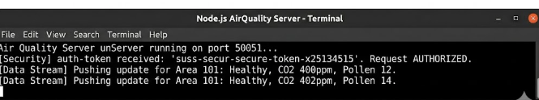
Figure 3: Server Side console logs, showing outputted behaviour

